IP CABLING TRANSMISSION – POE Repeater
ITEM NO.: IP04
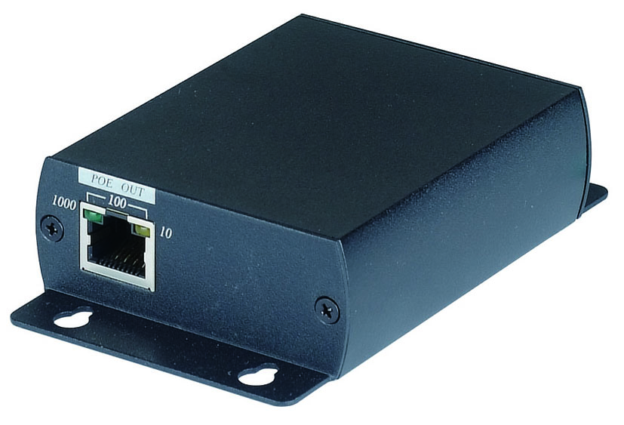

IP04 is a POE repeater to extend power and data an additional 100meters. Maximum range up to 300 meters by using one IP04 repeater, eliminating the need for additional switches, hubs and expensive fiber installations. It compliant with standard POE IEEE802.3af.

IP04 POE Repeater
- Extend of both power and data beyond 100 meters.
- Maximum range up to 300 meters under 10/100BASE-T.
- No external power required.
- Compatible IEEE 802.3af POE standard.
- Support 10/100/1000 BASE-T transmission rate.
- Built in LED status indication.
- Plug and play for easy installation.

Installation View:

Quick Installation:
- Connect the POE IN connector to a POE Source (such as a POE network switch), the power LED will be on and link speed LED will start blinking.

- Connect the POE OUT connector to a POE powered device ( such as an IP camera), the link speed LED will start blinking. If POE equipment provided by normal power, the POE equipment power LED will be on.

LED Indication for Link Speed:

10BASE-T: Yellow
100BASE-T: Yellow, Green
1000BASE-T: Green

IP04 itself provide data and power 150 meters，the power will drop as below by multi POE repeaters and long cable length application:

Max Device Power | CLASS 3 |  | CLASS 2
Max Device Power | MAX | MIN | MAX | MIN
Max Device Power | 12.95W | 6.5W | 6.5W | 3.8W
Range with POE switch | 0m |  | 300m
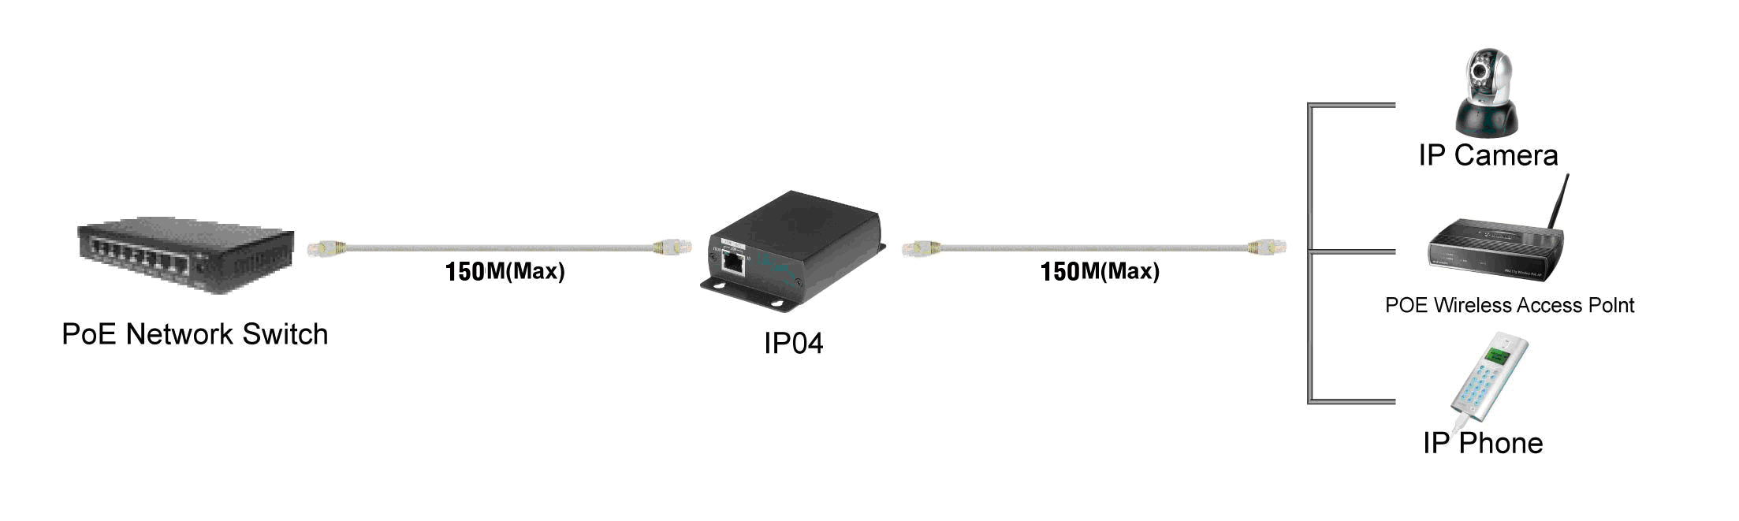

Panel View:

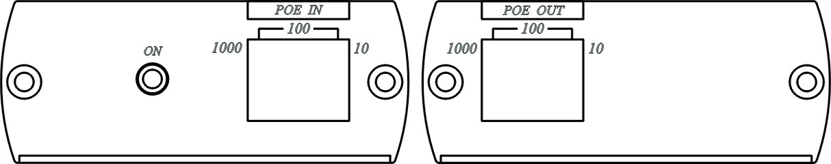

Troubleshooting:

- IP04 both end equipment must be at same link speed, 10BASE-T must work with 10BASE-T equipment，100BASE-T must work with 100BASE-T equipment。If both ends of equipment at different speed, then the data won’t be able to send out.

- The cable of quality will affect the transmission range based on POE equipment at 1000 BASE-T. If POE repeater auto setup to100 BASE-T, then reduce the cable length or change for better quality cable (CAT6 cable recommended).

3.. The power consumption is bigger based on 1000 BASE-T transmission, to use multi POE repeaters will be less to 2 units ( The power consumption of POE equipment must under 7W)

4 .IP04 power consumption is 2.2W (1000BASE-T is 5W), if your POE device
power consumption is over 10.5W ( 1000BASE-T is 7.5W ) will cause IP04
shut down and it will be auto re-boot after a few seconds.

5. The maximum distances above are typical for installations using 24AWG CAT5 cable or better. Actual limits depend on cable quality and POE device characteristics.

Specification:

ITEM NO. | IP04
Power & Data Input | RJ-45
Power & Data Output | RJ-45
Data Link | Pins 1,2、3,6、4,5、7,8
Power Link | Pins 4,5、7,8
Transmission Range | 150 Meters (MAX)
LED Indication | Power: blue, Link Speed: yellow, green
POE | IEEE 802.3af Standard, 48V、400mA、12.95W
Power Consumption | 2.2W (Max.) based on 10/100 BASE-T  5W(Max.) based on 1000 BASE-T
Temperature | Operation: 0 to 55°C, Storage: -20 TO 85°C, Humidity: up to 95%
Dimensions W x H x D mm | 130×67×27 mm
Weight g | 170g

